**ST. XAVIER’S COLLEGE**

**(Affiliated to Tribhuvan University)**

Maitighar, Kathmandu



**Computer Graphics Lab Assignment #3**

**Submitted by:**

Suman Malla

013BSCCSIT041

**Submitted to:**

|  |  |
| --- | --- |
| Er.Anil Shah  Lecturer, St. Xavier’s College |  |

**Date of Submission:** Tuesday, August 11, 2015

**STATEMENT: IMPLEMENT THE DDA LINE DRAWING ALGORITHM IN C++ BUILDER.**

**SOURCE CODE:-**

//---------------------------------------------------------------------------

#include <vcl\vcl.h>

#pragma hdrstop

#include "Unit1.h"

//---------------------------------------------------------------------------

#pragma resource "*.dfm"

TForm1 *Form1;

//---------------------------------------------------------------------------

__fastcall TForm1::TForm1(TComponent* Owner)

: TForm(Owner)

{

}

int x1,y1,x2,y2;

//---------------------------------------------------------------------------

void __fastcall TForm1::Button1Click(TObject *Sender)

{

x1=StrToInt(Edit1->Text);

y1=StrToInt(Edit2->Text);

x2=StrToInt(Edit3->Text);

y2=StrToInt(Edit4->Text);

int dx, dy, steps, k;

float incrx,incry,x,y;

dx=x2-x1;

dy=y2-y1;

if (abs(dx)>abs(dy))

steps=abs(dx);

else

steps=abs(dy);

incrx=dx/steps;

incry=dy/steps;

x=x1; /* first point to plot */

y=y1;

Image1->Canvas->Pixels[x][y]=RGB(255,0,0);

for (k=1;k<=steps;k++)

{

x = x + incrx;

y = y + incry;

Image1->Canvas->Pixels[x][y]=RGB(255,0,0);

}

}

**OUTPUT:-**

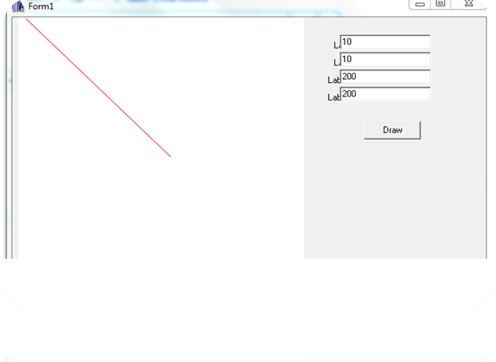

**CONCLUSION:**

Hence, By using the c++ and DDA algorithm we can draw a simple line.

**REFRENCE:**

[1]http://www.eazynotes.com/notes/computer-graphics/algorithms/dda-line-algorithm.pdf